12V 24AH
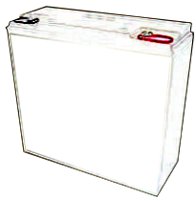

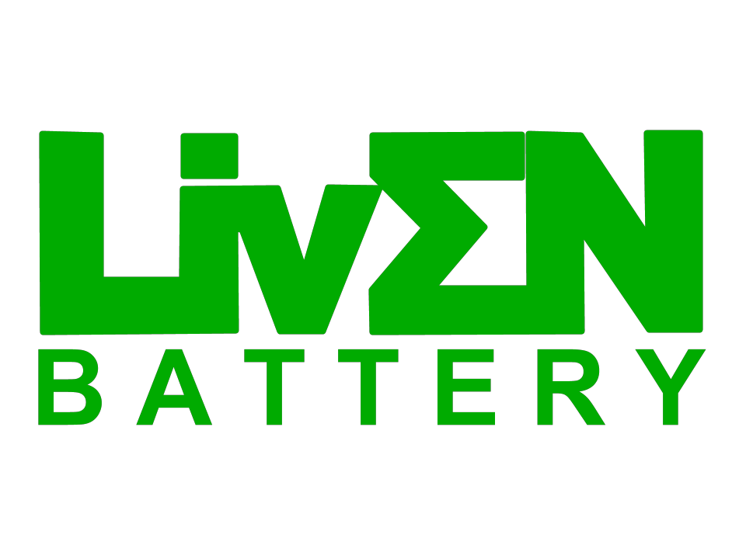

Specification:
LEV24-12
LEV series VRLA battery

LIVEN LEV Series
Cells Per Unit 6
Voltage Per Unit 12

Nominal Capacity 24Ah@20hr-rate to 1.75V per cell @25°C
Weight Approx. 7.00 Kg ±2% Internal Resistance Approx. 10.0 mΩ Terminal R5.1
Max. Discharge Current 288 A (5 sec)
Cold Cranking Ampere (CCA) 205A

Recommended Maximum Charging
Current 7.2A

AGM (Absorbent Glass Material) technology with gas

recombination. VRLA (Valve Regulated Lead Acid Battery). LEV (Liven Electric Vehicle) series is specially designed for frequent discharge deep cycle application. Maintenance- Free Sealed Lead Acid Battery.
Cycle use 1: Up to 260 cycles at 100% DOD.
Standby Use Voltage 13.7 V~13.9 V @ 25°C
Temperature Compensation: -3mV/°C/Cell

Cycle Use Voltage 14.6 V~14.8 V @ 25°C
Temperature Compensation: -4mV/°C/Cell

Discharge: -20°C~60°C

Cycle use 2: Up to 500 cycles at 50% DOD.

Application:
Operating Temperature Range
Charge: 0°C~50°C Storage: -20°C~60°C

• Electric Vehicle
• Golf cart
• Industrial equipment
• Floor machines

• Marine
• RV
• No-idle solutions
• Mobility
Normal Operating Temperature Range 25°C±5°C

LIVEN Valve Regulated Lead Acid (VRLA)
batteries can be stored for up to 6 months at

• Forklifts
• Aerial lifts and Robotics

Dimensions:
• Medical equipment
• Outdoor application
Self Discharge
25°C and then recharging is recommended.
Monthly Self-discharge ratio is less than 3%
at 25°C.Please charge batteries before using.
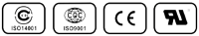

Length 181±2mm (7.13 inches) Width 77±2mm (3.03 inches) Height 170±2mm (6.69 inches) Total Height 170±2mm (6.69 inches)

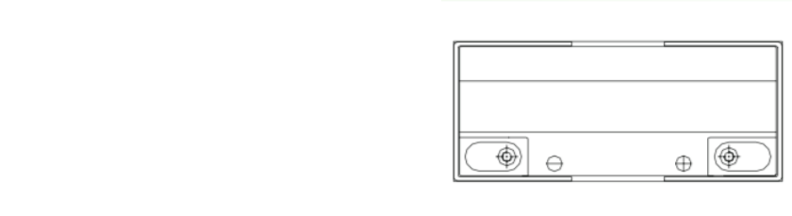

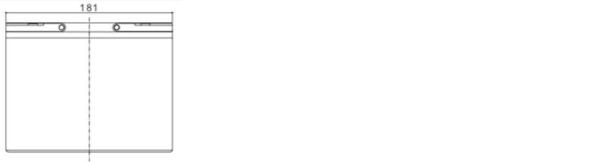
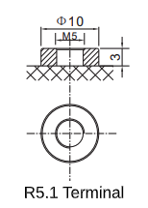
Drawing:
Container Material A.B.S. UL94-HB, UL94-V0 Optional.



Constant Current Discharge (CC, Unit: A) at 25ºC (77ºF)
F.V/Time | 5MIN | 10MIN | 15MIN | 30MIN | 1HR | 2HR | 3HR | 4HR | 5HR | 8HR | 10HR | 20HR
1.60V | 100.3 | 65.79 | 49.00 | 28.17 | 16.53 | 9.433 | 6.662 | 5.209 | 4.348 | 2.938 | 2.430 | 1.248
1.65V | 96.63 | 63.59 | 47.53 | 27.58 | 16.22 | 9.273 | 6.561 | 5.138 | 4.294 | 2.905 | 2.406 | 1.237
1.70V | 91.80 | 60.73 | 45.61 | 26.79 | 15.81 | 9.060 | 6.425 | 5.042 | 4.222 | 2.861 | 2.373 | 1.222
1.75V | 85.37 | 56.91 | 43.02 | 25.73 | 15.24 | 8.768 | 6.239 | 4.911 | 4.123 | 2.801 | 2.328 | 1.200
1.80V | 76.83 | 51.79 | 39.54 | 24.27 | 14.47 | 8.366 | 5.981 | 4.728 | 3.985 | 2.717 | 2.265 | 1.171
1.85V | 65.31 | 44.79 | 34.73 | 22.21 | 13.36 | 7.789 | 5.610 | 4.464 | 3.785 | 2.594 | 2.173 | 1.129

Constant Power Discharge (CP, Unit: W/Battery) at 25ºC (77ºF)
F.V/Time | 5MIN | 10MIN | 15MIN | 30MIN | 1HR | 2HR | 3HR | 4HR | 5HR | 8HR | 10HR | 20HR
1.60V | 1021.2 | 670.8 | 514.0 | 307.0 | 185.5 | 107.3 | 76.4 | 60.0 | 50.3 | 34.4 | 28.7 | 14.8
1.65V | 1009.2 | 666.0 | 509.0 | 305.0 | 183.9 | 106.2 | 75.7 | 59.5 | 49.9 | 34.1 | 28.4 | 14.6
1.70V | 969.6 | 643.2 | 492.7 | 298.0 | 179.8 | 104.1 | 74.3 | 58.5 | 49.2 | 33.7 | 28.1 | 14.5
1.75V | 918.0 | 613.2 | 471.5 | 289.1 | 174.3 | 101.2 | 72.4 | 57.2 | 48.2 | 33.0 | 27.5 | 14.2
1.80V | 840.6 | 567.8 | 439.4 | 275.5 | 166.2 | 97.1 | 69.7 | 55.3 | 46.7 | 32.1 | 26.9 | 13.9
1.85V | 727.2 | 499.9 | 391.6 | 254.6 | 154.6 | 90.8 | 65.7 | 52.4 | 44.5 | 30.7 | 25.8 | 13.4

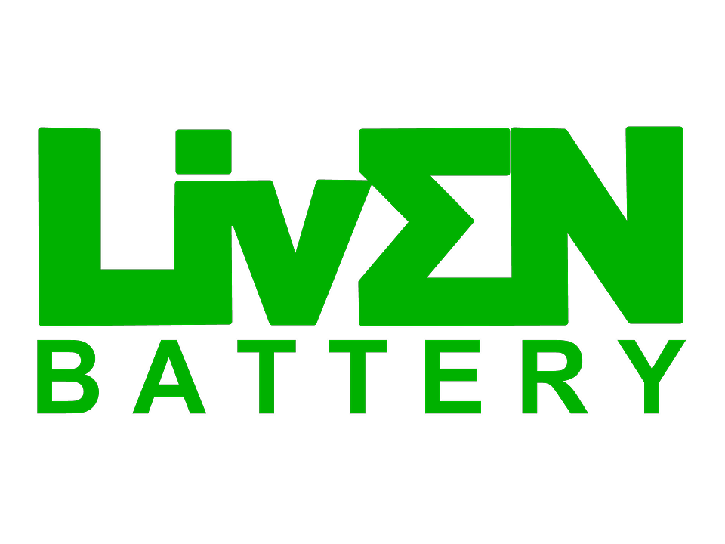
12V 24AH LEV series VRLA LEV24-12

(Note) All above information shall be changed without prior notice, LIVEN Battery reserves the right to explain and update the latest information.

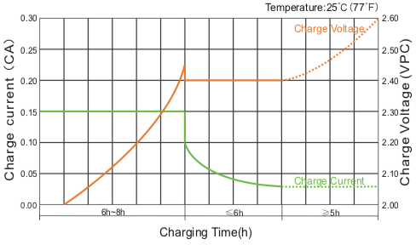
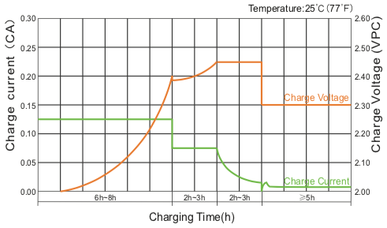
Charge Characteristic Curve For Cycle Use (IIUU) Charge Characteristic Curve For Cycle Use (IUI)

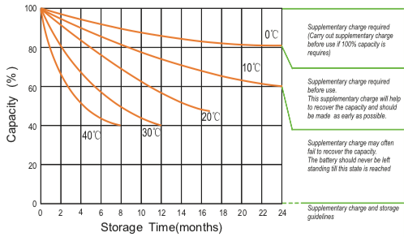
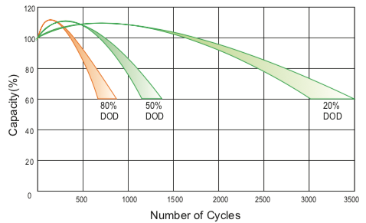
Cycle Life In Relation To Depth Of Discharge Storage Characteristics

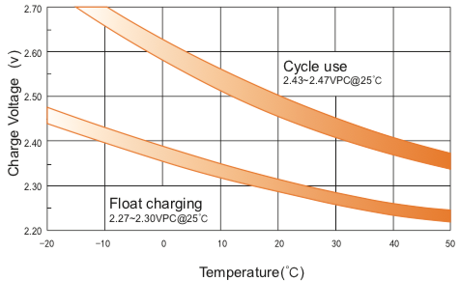
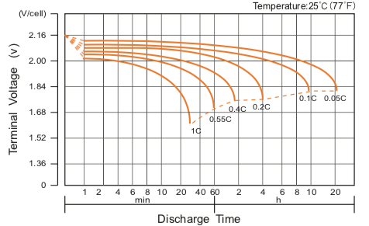
Discharge Characteristics Curve Relationship Between Charging Voltage And Temperature

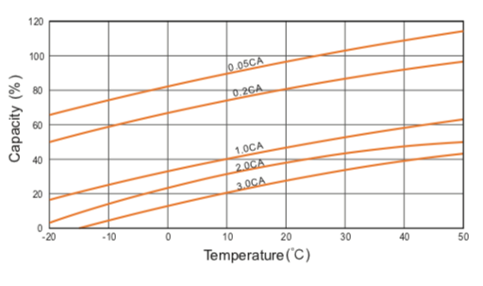
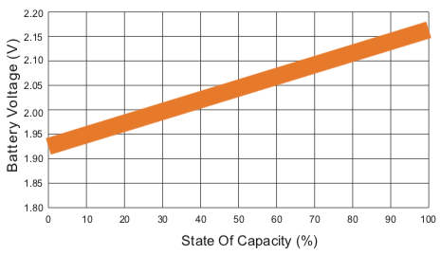
Relationship of OCV And State of Charge (20ºC) Temperature Effects On Capacity

V00 19/02

